CAMP WESLEY report for FOL 2019
This past summer was very active in building and renovating some of most needed things, like storage for camping equipment and rewire some of wiring in big building. Storage was built into sea container that was donated from Ireland, it now gives opportunity to keep all camping equipment in one place.
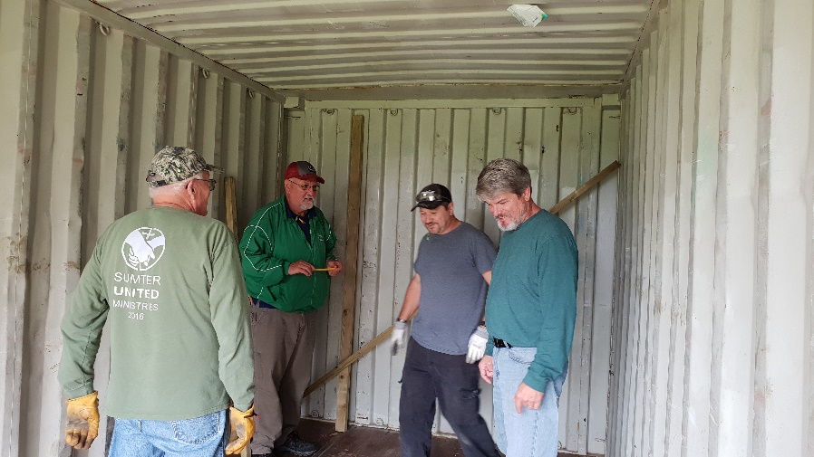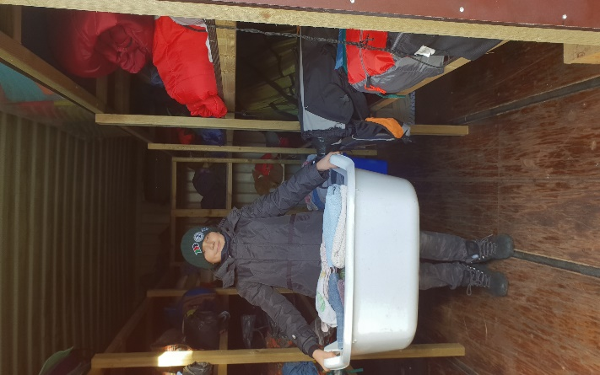
Really big help and support in practical works were three mission teams who came to Wesley camp in summer, they did come with purpose to work and accomplished amazing work. I want to say thanks to Dale Wilbanks, Richard Rudesill and Tony Rowell and their teams for their active help in this summer.
Our local Methodist church members actively take lead in volunteer jobs through whole summer and all work days. Congregation of Liepaja finished building volleyball field in Wesley camp, so kids, staff team and all teachers actively played it during whole summer.
One more big project got done this summer, the outside stage was finally built. This was one of the biggest projects of past two years and it was amazing to see how many people did put their hands on it so our camp is more enjoyable for children who are camping. 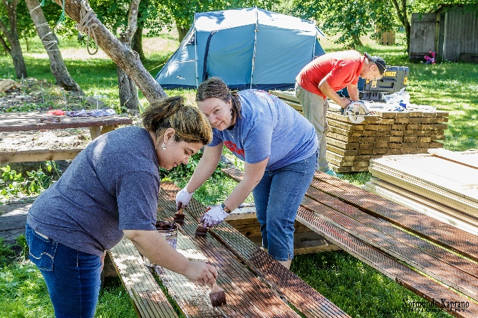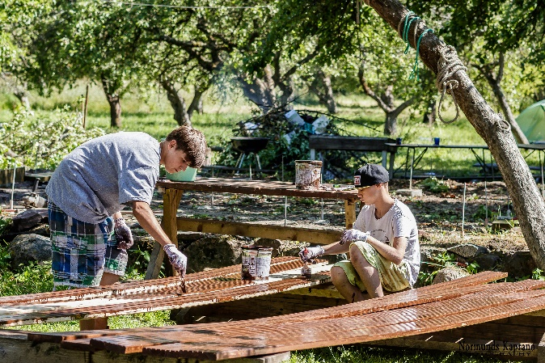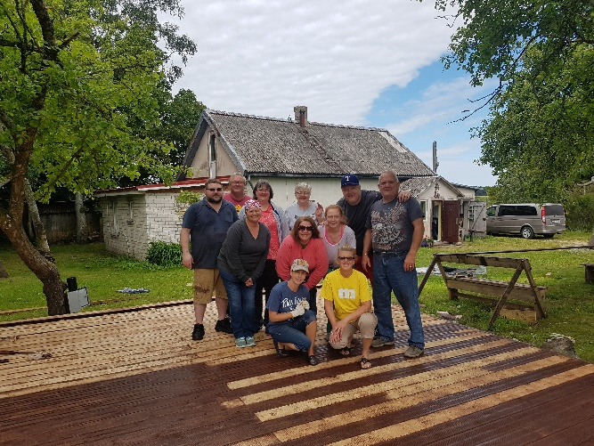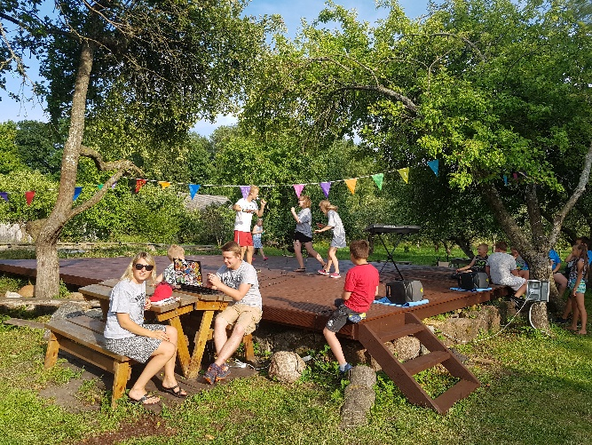

If we are talking about big projects, I can’t miss the new cabin. We feel so blessed with it, this project shows that there is no thing too big for God. Just this spring we got all paperwork done for new cabin and this summer some children will have opportunity to try it out. We still need to furnish it but those are already small things comparing to all what’s done and we are looking forward to have more cabins so all children who are coming camping can sleep inside.
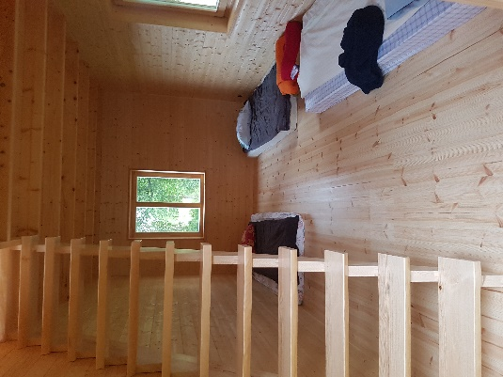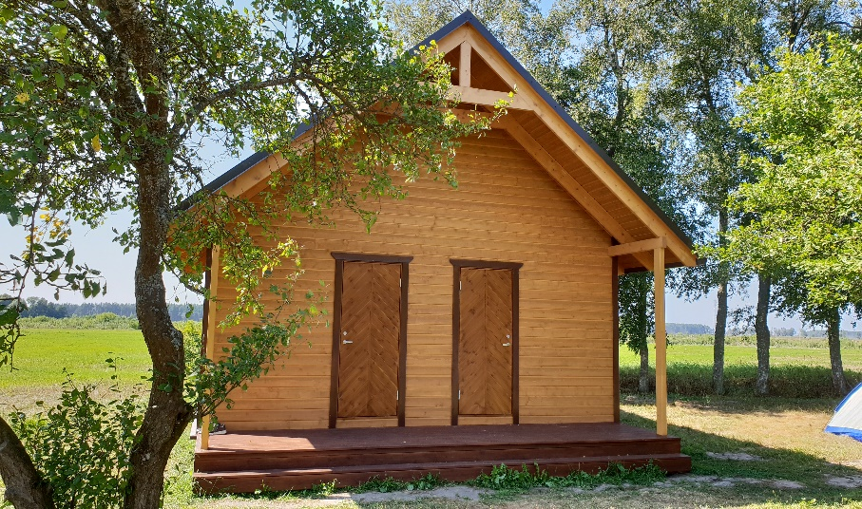

When we talk about challenges that we did face last year, I have to say that funding still is the biggest challenge through the year, also not enough active staff volunteers and leaders who are strong and can teach God’s Word to kids and youth. For solution we asked our pastors and active members to join camps and work together with the team.
Problems with electricity was the biggest challenge last year. Our incoming power line is 16 Amps and when we plug in all that we daily use in camp, the most important is kitchen, we are already on border to 16 Amps. For solution we called several times the repair service who replaced the electricity switch that had already started melting. Temporary solution was to turn on only two of the most needed big devices, for example, water boilers or ovens and cooker. We are still looking for the best long-term solution, to upgrade the incoming line power or to buy our own generator.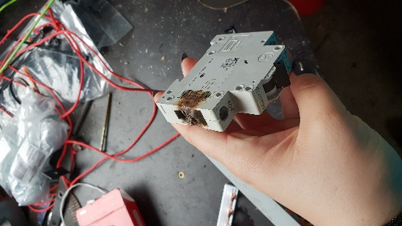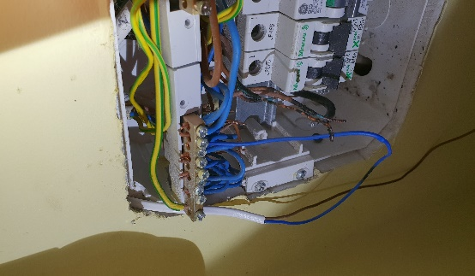
Through all year there were about 550-600 hundred people reached with God’s Word at Wesley Camp. Those were people from different ages, from newborns till elderly who are coming to different events to Wesley camp.
This last summer in teens and children camps we had many young people who came from non-Christian families, and to many of them those camps were the first opportunity to hear about God. In last day of camp, they have service where they are invited to accept Jesus as their Savior. In that moment we can feel God is between us, many of young people are on their knees in that moment, they open hearts to God, they give their lives to Him. And we never know how this just planted seed will grow, but I know that it will be growing in the way God has planned. I think that is the most important part of each camp and event made at Wesley Camp, to plant this seed of God’s Word, to let people meet God for first or not first time to experience how great He is.
One little 10-year-old boy who came from a family who never went to church, his mom was very worried how it will be because he never likes to be in contact with same age children. First day boy did not come out of his tent, and was hiding from everyone in every possible way, in next day I saw him being little bit more involved in all activities. In one of next days I did catch him alone singing worship song, as long no one saw him. And after some time, I asked his mom how her son was doing, she said there has something changed in him, but she does not understand what it is.
Camp Director Anita Ercuma
